Booking Instructions
Step 1: Click the language switch at the top-right corner of the page and select English to change the interface language.
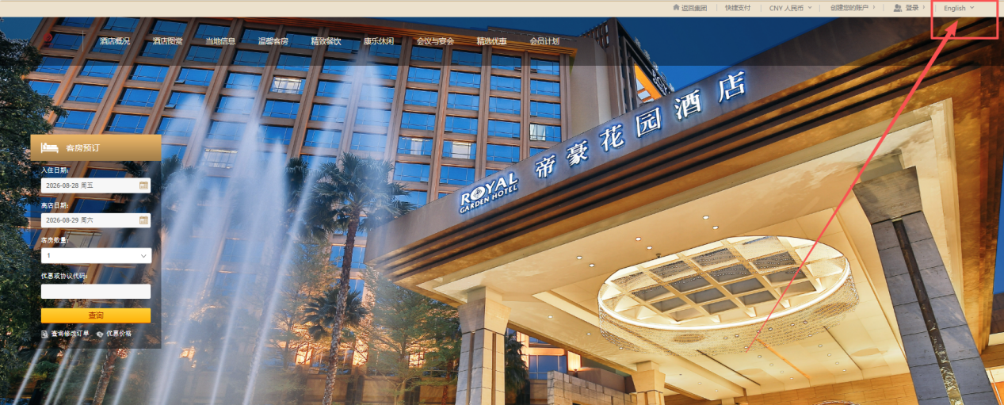
Step 2: Enter your check-in and check-out dates.
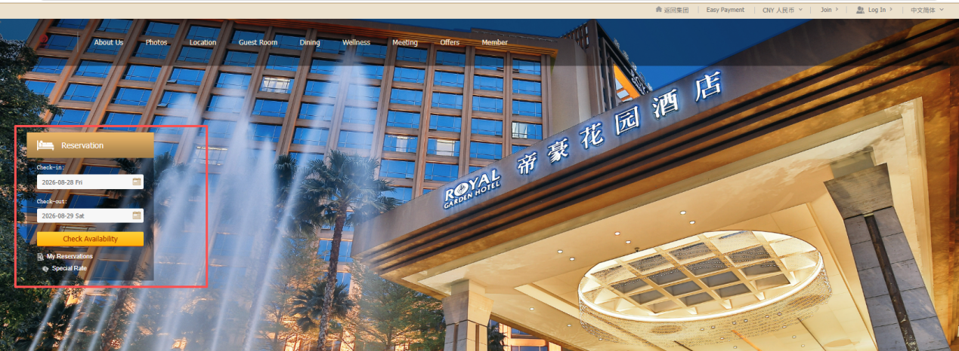
Step 3: Input the promo code “B05”, then click on one of the first two room options labeled with the conference name — these are the only ones eligible for the special conference rate.
Note on Breakfast:
- The Deluxe King Room with Garden View includes one complimentary breakfast daily.
- The Deluxe Twin Beds Room with Garden View includes two complimentary breakfasts daily.
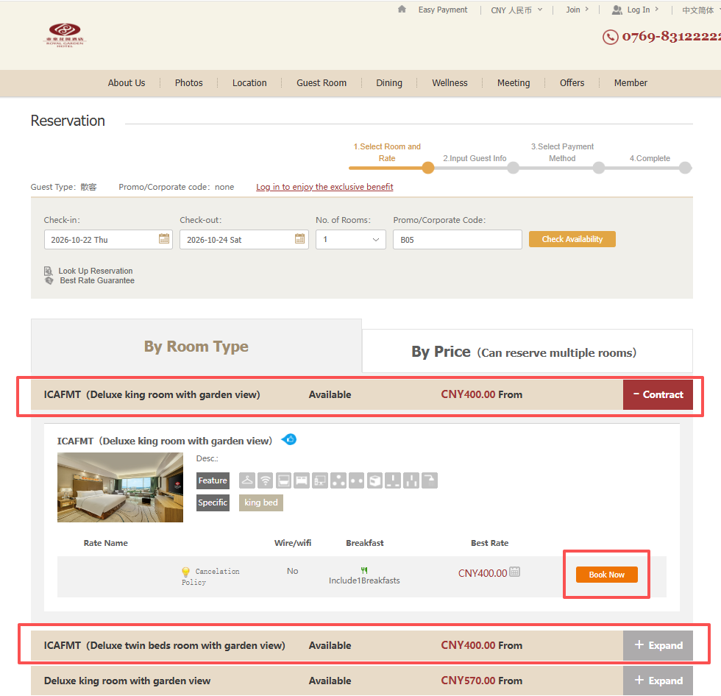
Step 4: Complete your personal information and submit your reservation. Payment will be made at the front desk upon check-in.
